ARGUS
PERFORMANCE TESTING RESULTS

Prepared By: PTG
Date: 2013/05/23
Version: 1.0
Status: {Initial}

Revision History

Date | Version | Description | Author

1. Executive Summary
The performance testing for Argus started from 2013-03-23 to 2013-5-23. This testing aims to evaluate the performance of Argus Network application as well as help Argus team to find potential performance related bottlenecks, bugs and errors. We applied JMeter to execute test cases in heuristic way to evaluate response time and throughput of key scenarios. JMeter’s Aggregate Report was applied to record the Max Response time, Average Response Time, Min Response time and 90th % time. The performance testing efforts thoroughly reveal the quality of Argus Network Application to reduce the potential risks before production.
The following subsections will briefly describe the important observations from tests. We draw conclusions with the analysis based on test data, monitoring data, profiling and tuning.

Important observations
In this section, the important statistics and observations are given. Detail test data is displayed in the following sessions. The following are the key observations:
- The following pie graphs show the proportion of response time ranks of all the test web pages or actions. We simulate 1Vus, 5Vus, 10Vus, 15Vus and 20Vus to visit Argus system separately. Each thread will start 8 seconds after the previous thread was begun. Each virtual user should execute the test 10 times. The think time between each action is 0.3 second. The response time ranks are generally classified into five types as follows: Excellent (<1s), Good (1s-2s), Acceptable (2s-5s), Fair (5s-10s), Poor (>10s)
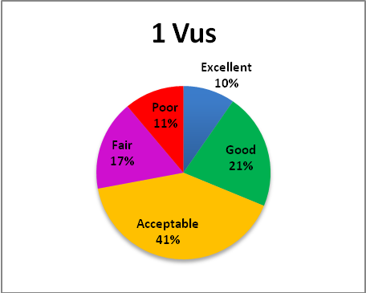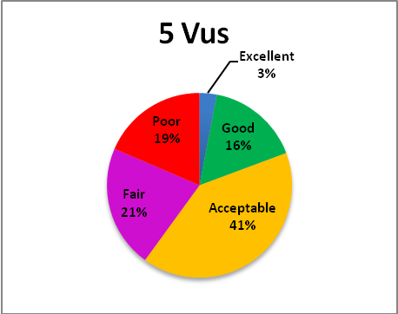
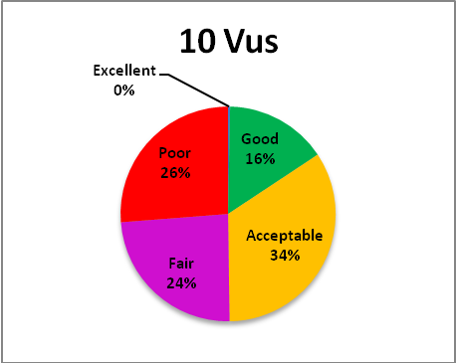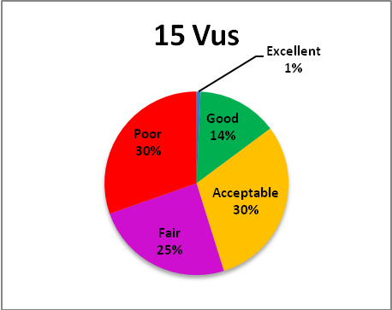
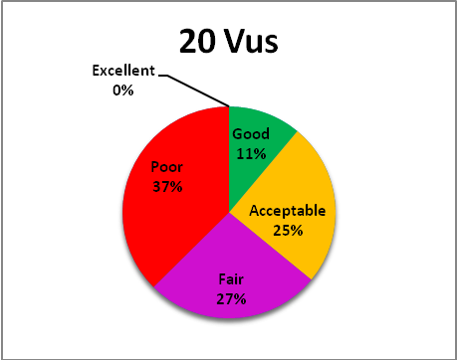
As can be seen, Poor and Fair have the largest percentage, while Excellent has the smallest proportion, which always accounts for less than 5%.
It must be pointed out that Poor plus Fair is always over 50% when virtual user are more than 10, and it is also need to note that the proportion of Acceptable is always two times as big as Good.
- After running all the test cases under different test loads, we find that, it always costs too much time on database interaction. For example, the response time is always much too higher than the other steps when you click on Save, Edit or Detail button.

Important conclusions
- It can be clearly concluded that from these pie graphs, the whole system does not perform well when the virtual user is more than 10.
- It always costs too much time on database interaction. It is caused by high CPU usage.

2. Performance Testing Goal
The performance testing is deemed complete when all of the testing requirements are met. No specific performance goals are set for the Performance of Argus 2686 application. So we decide to use common standard of the User Experience Time, which are generally classified into five types as follows: Excellent (<1s), Good (1s-2s), Acceptable (2s-5s), Fair (5s-10s), Poor (>10s).

3. Environment Description
This section describes environment setting for performance testing to Argus Pharmacy-Network system. In this testing, we apply the development environment as the testing environment. The following section will describe the detail setting of the development environment.

3.1 Development Environment
The Argus Pharmacy-Network system, deployed off-site, contains two server instances: Web Server and Database Server. Currently, the production environment is undefined. The development environment can be important reference for building future production environment. Thus, performance evaluation of development environment can partially predict the performance in both development environment and provide decision support for building up production environment.
The hardware and software setting of development environment are listed as below:
  - 20*CPUs(PowerPC_Power7), 3300 MHz CPU clock rate, 16GB memory
  - OS： AIX 7.1.1.16 TL00
  - Web sphere Application Server - ND, 7.0
  - DB2 version: 10.1

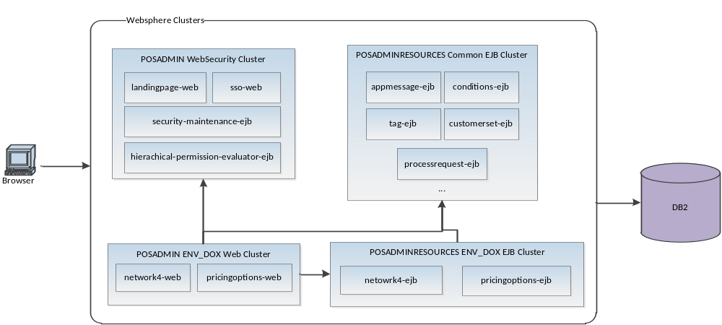

Figure 1 - Logical view of Argus Pharmacy-Network Development Environment
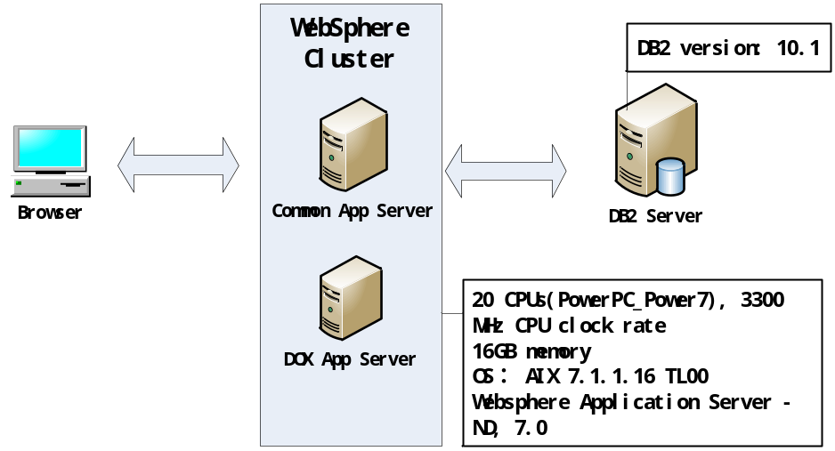

Figure 2 - Physical view of Argus Pharmacy-Network Development Environment

4. Workload Characterization
Test Load is generated by creating virtual users, in a simulation case where the goal is to reflect how users utilize a system. In order to do the workload characterization, it is necessary to investigate and analyze business process. This can help characterize the system workload, and then use these representative workloads to determine what the system performance will look like when it is run in production on significantly large workloads.
  - Workload Distribution
The workload characterization is comprised of two steps. The first step is to investigate and analyze business process and model the software system. The second step is to make sure the distribution of each step and run test cases based on this distribution.

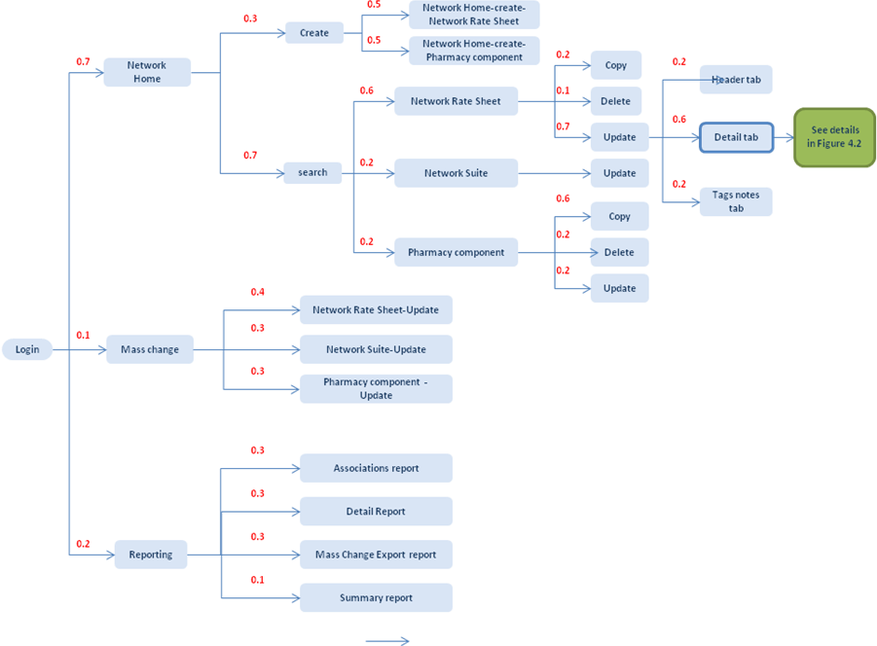
Figure 4.1 System Workload

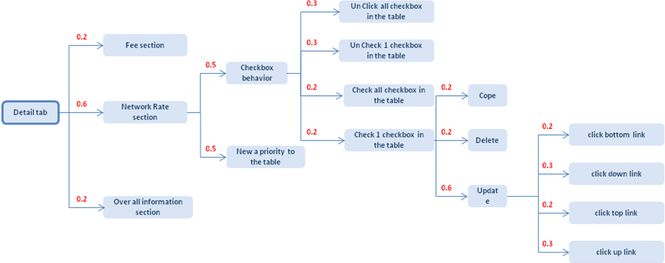
Figure 4.2 Workload of Detail tab

4.2 Workload Scenarios
Through the earlier survey and study, observe and data -generation on the system, we found that, this system does not perform well enough. So we design the following low load test scenarios.
We simulate 20Vus to visit Argus system. Each thread will start 8 seconds after the previous thread was begun. Each virtual user should execute the test 100 times. The think time between each action is 0.3 second.

5. Test results

  - CPU usage under 20 Vus.
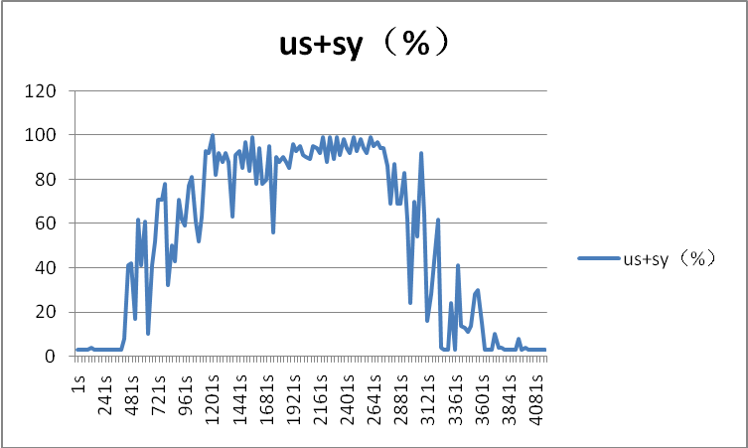
us (user CPU): This is the amount of CPU that is servicing user tasks.
sy (system CPU): This is the percentage of CPU being used to service system tasks.
Note that all of the CPU metrics are expressed as percentages.
The CPU values (us + sy) is always sum to 90 when 20Vus are visiting Argus system. Because of the testing environment is also the development environment, some other programs which will generate many processes are running together with us, the accuracy of this test is affected by these factors.

  - Top 10 Under Performance Actions
Top 10 Under Performance Actions | Average response Time(ms)
Create-Network Rate Sheet-Enter Tags/Notes parameter | 65818
Network Home- Search-Network Suite-Update-Detail-Save | 64424
Network Home-Update Tags/Notes tab-save | 64169
Mass Change-Network Suite-Update-Edit | 60572
Network Home- Search-Network Suite-Update-Search | 59673
Mass Change-Network Suite-Update-Save | 49133
New a Priority to the table-Network Rate section-New a Priority to the table | 42095
Network Home-Update Tags/Notes tab-search | 36998
Network Home-Update Tags/Notes tab-Detail | 33540
Creat-Network Rate Sheet-click-next1-buttton | 28682
After running all the scripts we sum up above 10 under performance actions. Most actions are about database interaction.

  - Average response time

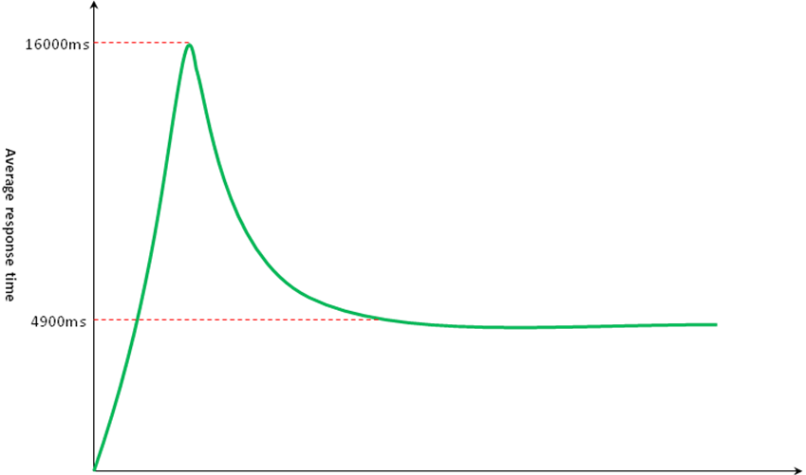
The response time which is recorded by Jmeter should be the sum of Server Response Time(Ts) and Network Response Time(Tn). We keep on Pinging the server of Argus system every 10 seconds and the Average Server Response Time is 292ms.
As is show on the above curve chart, the average response time grows rapidly at the begin time and reaches to the highest point at a very short time. Then the trend is towards to a decrease and remains a steady number of 4900ms.
There are three reasons which are about to lead to the above phenomenon:
- System contains performance deficiency at the initial phase which is needed to be future optimized. For example, it always costs too much time on database querying.
- System uses cache mechanism, it is not a performance deficiency.
- The inherent phenomenon which is caused by system architecture design. For example, system won’t establish the connection between application server and database until receive the first request and the connection will not be released during the subsequent stage. We can’t define it as a performance deficiency before making sure it with system architecture, developer and the end user.

